**Abstract-** Although the advancement of IoT and digital automation systems, there are many old system in our hospital management and communication we still follow manual patient registration and we don’t even have any special plan for emergency unfortunate road accident.

Though some substantial progress was made for improving the sharing of patient medical information among healthcare providers, professionals still need to address the issue of efficient electronic medical records

We thought about a plan which may help people with emergency medical treatment at any unwanted accident or disaster situations. Thus, real-time information presents a persistent challenge to the emergency response community. In emergency situations, particularly with unconsciousness. One can get basic emergency information easily of victim and follow the guidelines. Getting every possible information with root plan of nearby hospital and pharmacy may save the victims life. Hospital management system may digitalized with registration, treatment and records having the user-friendly system.

Another important problem we have that our doctors are not enough interested in using computers to treat patients. To overcome this problem, we have integrated the system into the Android app, which will be a lighter and more effective solution for the entire healthcare system and ensured to eliminate all physical constraints of hardcopy documents and to allow prompt access to medical charts or patient records.

As the present paper demonstrates, our major aim was to design an RFID-based real-time system application and database that would provide efficient means to perform essential information management for emergency care across hospital and country boundaries.

**System design** is the phase that bridges the gap between problem domain and the existing system in a manageable way. This phase focuses on the solution domain, how to implement.

It is the phase where the SRS document is converted into a format that can be implemented and decides how the system will operate.

This section describes the conceptual design of our system and the methodology adopted for this work including the systematically organized different stages of the research in conjunction with the detailed implementation features of the proposed system. In addition, it clarifies the structural components of the proposed system and their integration to achieve the research aim.

In this phase, the complex activity of system development is divided into several smaller sub-activities, which coordinate with each other to achieve the main objective of system development.

### **System Architecture**

A system architecture is the [conceptual model](https://en.wikipedia.org/wiki/Conceptual_model) that defines the [structure](https://en.wikipedia.org/wiki/Structure), [behavior](https://en.wikipedia.org/wiki/Behavior), and more [views](https://en.wikipedia.org/wiki/View_model) of a [system](https://en.wikipedia.org/wiki/System).  An architecture description is a formal description and representation of a system, organized in a way that supports reasoning about the [structures](https://en.wikipedia.org/wiki/Structure) and [behaviors](https://en.wikipedia.org/wiki/Behavior) of the system.

A system architecture can consist of system [components](https://en.wikipedia.org/wiki/System) and the sub-systems developed, that will work together to implement the overall system. There have been efforts to formalize languages to describe system architecture, collectively these are called [architecture description languages](https://en.wikipedia.org/wiki/Architecture_description_languages) (ADLs)

In this section, we describe the system architecture of IOT Based Personal Health Card and License Management System which consists of Admin, Authentication, User, and Entrance Display within android and web application.

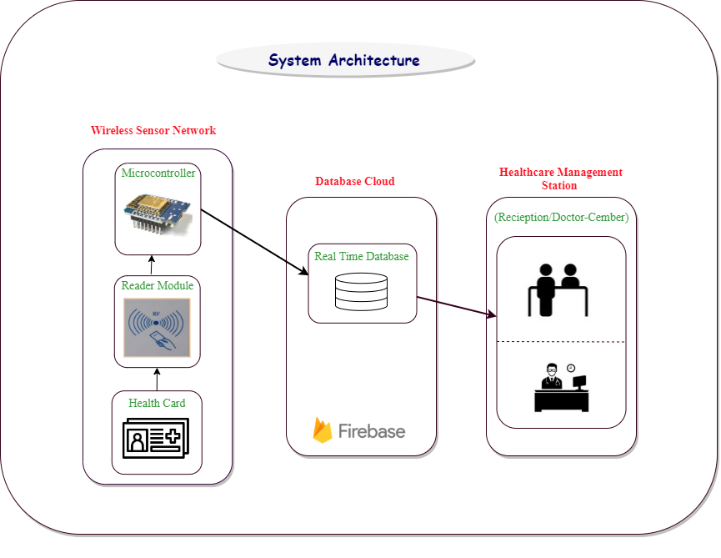

Figure 3.3.1: System Architecture

Here we use WeMos D1 mini ESP8266 as a micro controler and RFID card as a reader module we built a personal demo card [fig 3.2.1] which have some basic information like name , email, age, blood-group, phone number in its front side and there is a QR code on its back one can easily scanned this card and get the basic information of patient from our firebase database and get our service for free.All they need is just install our application even without registration one can get our services as a guest user.

Google MAP/Place API

## foundPlace.png PlaceDirection.png

Figure 4.3.9 Explore direction

Figure 4.3.8 Selected location

Introducing a simple way to add Google's rich, local information to your maps. This turnkey solution lets you show accurate details for nearby places, so users can see ratings, reviews, photos, and directions without ever leaving your web app. Plus, you can customize it to match your brand.

User can give his feedback as expectations in [figure 4.3.8] one can rate the hospital after being served as like Google map rating. One can easily find out the root plan and exploring around without any complication.

The Places API is a service that returns information about places using HTTP requests. Places are defined within this API as establishments, geographic locations, or prominent points of interest.

Each of the services is accessed as an HTTP request, and returns either an JSON or XML response. All requests to a Places service must use the https:// protocol, and include an API key.

The Places API uses a place ID to uniquely identify a place. For details about the format and usage of this identifier across the Places API and other APIs, see the [Place IDs](https://developers.google.com/places/web-service/place-id) documentation.